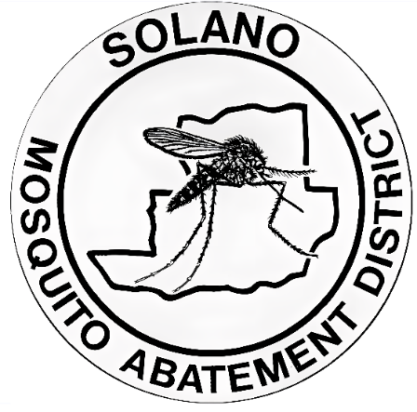
Public Advisory Update
August 22, 2024

Adult Mosquito & Wide Area Larvicide Treatment
The Solano County Mosquito Abatement District (SCMAD) completed all needed treatments to prevent the spread of Aedes aegypti on 8/22 in the city of Dixon and SCMAD will not be treating on 8/23.
The next set of treatments are set to take place 8/29, 8/30, 9/5, 9/6, 9/12, and 9/13 between the hours of 12:00am to 5:00am. Updates of completed treatment operations will be provided as information becomes available.
Residents are advised to take preventive measures to reduce the spread of this mosquito by inspecting their properties for standing water, and report day biting mosquitoes. The District will continue to monitor the area closely.
The treatment area includes the area below.
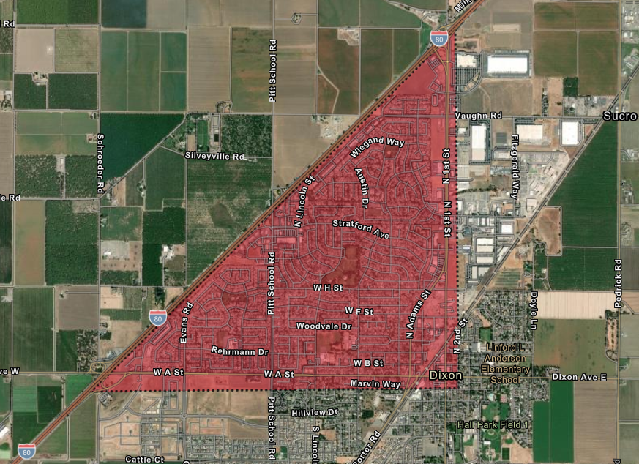

Use the link below to access an interactive map.
https://solanocountymosq.maps.arcgis.com/apps/instant/notification/index.html?appid=f897924acb6540ffb3b824bd5c1867fe
Information About Wide Area Larvicide Treatments
When a certified vector-control technician performs mosquito treatments according to the product’s label, the risk to humans, pets, wildlife, and the environment is minimal. As an extra safety measure, families are advised to stay indoors and keep windows and doors closed during the treatment window.

The Wide Area Larvicide Spray (WALS) is a method of larval control that uses a naturally occurring bacterium to kill mosquito larvae in water before they emerge as biting adults. Controlling mosquitoes at the larval stage is the foundation of most mosquito control programs in California. This method uses a powerful truck-mounted sprayer that combines high volumes of air with low volumes of liquid larvicide mixed with water, efficiently treating a wide range of mosquito breeding sites. The system allows the larvicide to drift into small, hard-to-reach breeding areas. The truck-mounted equipment produces a loud noise during operation, but this treatment only affects mosquito larvae.

For more information on the product being applied, please refer to the links below for the product label and safety data sheet.
https://www.solanomosquito.com/files/5edaccac8/VectoBac-WDG+label.pdf
https://www.solanomosquito.com/files/de514b99e/VectoBac-WDG+SDS.pdf
The video below provides more information on WALS treatments.
https://youtu.be/wfRSlMK6fwM
Information About Adult Mosquito Treatments
When a certified vector-control technician performs mosquito treatments following the product's label, the risk to humans, pets, wildlife, and the environment is minimal. As an extra safety measure, it is recommended that families stay indoors and keep windows and doors closed during the treatment window. The insecticide breaks down rapidly upon exposure to morning sunlight.
The District uses ultra-low volume (ULV) spraying techniques, which greatly reduces the chance of adverse effects from inhalation or skin contact. All insecticides used in the mosquito management program are approved by the EPA for use in public spaces and are widely employed by vector control departments throughout California.
For more information on the product being applied, please refer to the links below for the product label and safety data sheet.
https://www.solanomosquito.com/files/dbfd2d92e/MGK+Label.pdf
https://www.solanomosquito.com/files/b9113a1ad/MGK+SDS.pdf

Information About Aedes aegypti
Aedes aegypti is a highly significant vector in public health due to its role in transmitting several dangerous viruses, including dengue, Zika, chikungunya, and yellow fever. These diseases can lead to severe health complications, neurological disorders, birth defects, and in some cases, death.

Controlling Aedes aegypti is critical because this mosquito species is highly adaptive and thrives in urban environments. They are aggressive daytime biters, often residing close to human dwellings, making it easier for them to spread viruses quickly. The ability of Aedes aegypti to breed in small amounts of standing water, such as in discarded containers, makes them difficult to control once populations are established.

Reducing the population of Aedes aegypti early helps to prevent the mosquito from establishing and minimizes new risks of mosquito-borne diseases spreading within communities.

Prevent Mosquito Breeding On Your Property
To reduce mosquito breeding on your property:
Check for standing water.
Drain standing water. Empty items like flowerpots, planter dish, pet dishes, buckets, and old tires. Clean Regularly, wash bird baths and pet bowls weekly.
Repair leaky faucets and broken sprinkler heads. Avoid over-watering.
Ensure window and door screens are intact, have no holes, and fit well.
Keep swimming pools at proper water levels for circulation and filtration.
Request free mosquito fish for neglected pools, ornamental ponds, water troughs, and other artificial bodies of water.

About The District
SCMAD plays a crucial role in controlling mosquito populations across both incorporated and unincorporated areas of Solano County, which spans over 900 square miles. Established in 1930, SCMAD has been committed to protecting public health and improving the quality of life for residents by reducing the risk of mosquito-borne diseases. Over the years, the district has implemented a variety of strategies, including surveillance, public education, and environmentally responsible treatments, to effectively manage mosquito populations. The dedicated efforts of SCMAD ensure that the community remains safer from the threats posed by mosquitoes, West Nile virus and other vector-borne illnesses.

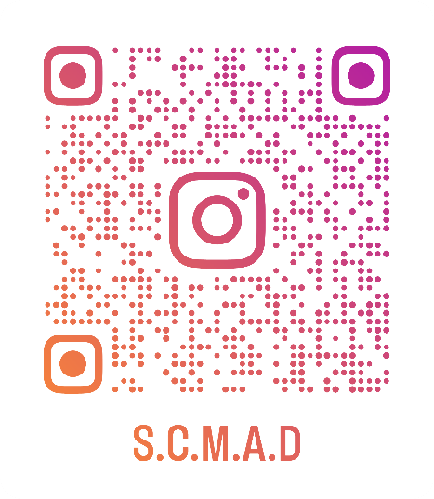
Contact us at
Office phone number 707-437-1116
solmad@solanomosquito.com
Website www.solanomosquito.com
Sign up for email notifications at
www.solanomosquito.com/stay-in-touch
Follow us on Instagram

